St James Township, Beaver Island MI
Township Board Financial Report for December 31, 2022
Fiscal Year 22 (April 1, 2022 – March 31, 2023)
November Report: 9th month/12 = 75% of year elapsed

Charlevoix State Bank Account Balances
and Revenues and Expense Report
Account | Last Month  12/31/22 | Previous Mo.  11/31/22 | Last Year  12/30/21 | To-Date  Revenues  01/10/23 | To-Date Expenses  01/10/23
General Fund | $74,339.35 | $71,371.74 | $257,882.95 | $429,064.54 | $580,156.50
Municipal Dock | $95,045.19 | $95,809.13 | $65,843.26 | $252,171.54 | $258,499.81
Sewer Use | $23,661.30 | $19,119.34 | $18,717.71 | $43,393.43 | $28,648.78
Sewer Cap. Impr.* | $17,102.95 | $17,098.64 | $7,087.34 | NA | NA
Street & Road | $222,039.61 | $217,519.79 | $306,835.95 | $37,316.61 | $169,026.25
Lighthouse | $5,444.63 | $5,444.17 | $5,439.19 | NA | NA
Reserve* | $25,081.35 | $25,066.81 | 75,010.68
*The Sewer Capital Improvement and Reserve funds only reports quarterly, so the nearest quarter information is reported herein

Account Notes
Account | Monthly Highlights
General Fund: | The majority of this account’s funds are from property taxes and grants not involving the below accounts. Large expenses relative to one-time costs of returning an overpayment of ARPA funds ($60,136), purchasing the new township pickup, snowblade, and trailer (over $40,000), as well as costs associated with re-roofing the Deputy Residence ($26,400) have affected this fund. Other than those expenses, payroll remains the greatest expense for the township with greater hours worked during the summer months.  Additional revenues are expected, these include: $216,601 in winter taxes and $49,489.36 from the State for the Campground and transfer of general fund costs incurred via the Dock or Sewer funded work. By 2/1/23 the $50,000 from the reserve fund will be repaid. We are awaiting a reimbursement payment for TIS in the amount of $8,743.65.
Municipal Dock: | This enterprise fund (no millage) is in good shape. More detailed financial information will be provided in a later scheduled Board Packet. The repair of the floating docks may not be covered by insurance (wind damage not water damage is covered).
Sewer Use: | This enterprise fund (no millage) does not receive tax dollars. Sewer users continue to pay in a timely manner. Annual sewer study will be completed in November. The final pumping cost was $17,220 for 22,800 gallons.
Sewer Capital Improvement: | This enterprise fund (no millage) was set up to save money for capital improvement projects related to the sanitary sewer.
Street & Road: | This millage-based account is stable; however, the every-three-year purchase of gravel ($131,160 in 2022) will reduce any surpluses as will any township-based road improvement.  $144,000 was paid for the gravel costs and two dust control applications.
Lighthouse: | This fund is set up to save money for improvements to the Whiskey Point Lighthouse. Funds come from 50% of the donations during summer tours sponsored by BIHS. Painting the tower needs to be assessed.
Other Monthly Notes: A second page is added to this report which gives board members a snapshot of Charlevoix State Bank funds on the day the snapshot was taken (not the end of the previous month).

Charlevoix State Bank
St James Township Account Status as of January 10, 2023

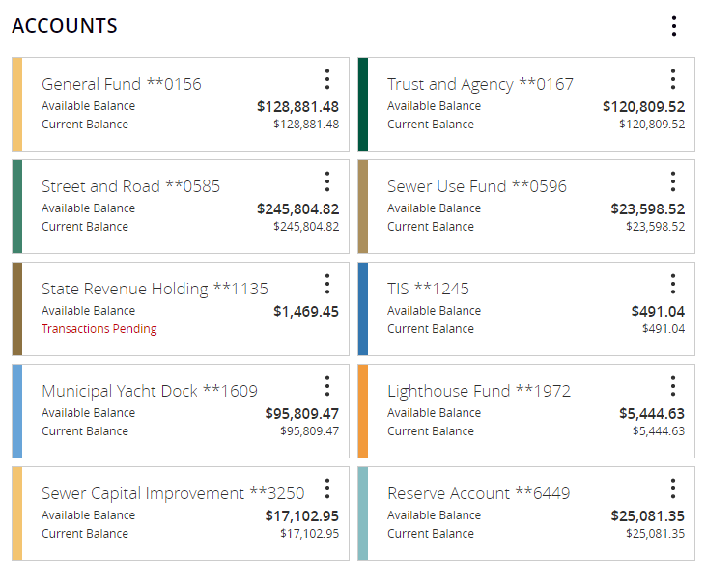
Note: The large Trust & Agency amount is due to the incoming property taxes that are for other entities and are being sent to them. A number of recently sent checks to island entities have yet to be cashed.

